**Section03 Develop Azure Infrastructure as service compute solutions**

**Notes: -**

**1-in this module we will interact with IASS (infrastructure as service) which specify how to create Azure VM and management by yourself**

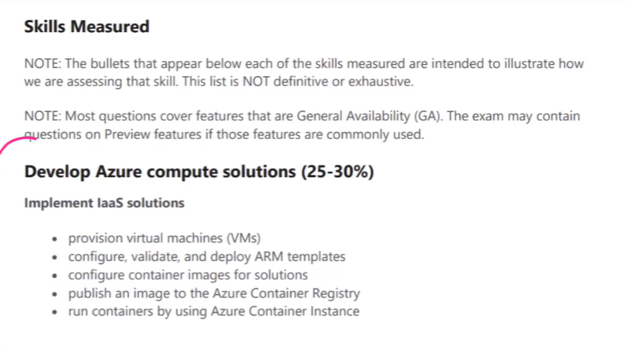

**2-Virtual machine service: its service allow you to deploy your VM on azure platform**

**3-you can create 2 VM one at the app service level and the other for the database level**

**Benefits**

**A-azure VM service is that the infrastructure is completely managed by azure**

**B-azure VM service based on pay as you go which means as you power on VM it will charge, when you turn off you don’t charge anything.**

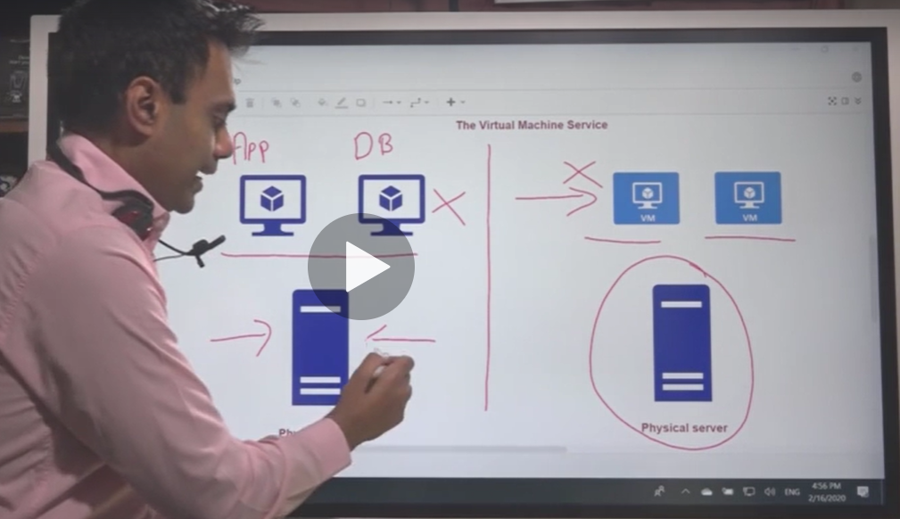

**Lesson02 Deploying azure VM service**

**Notes:-**

**1-when deploying VM, multiple resources are created also**

**A-Azure virtual network: which represent the gateway of the azure VM that you can configure the allowed IP address and the protocols such as SSH ,**

**RDP (remote desktop protocol)**

**B-O. S Disk and data Disk**

**C-Network Interface (which used to connect the VM with the network with private and public IP address)**

**D-NSG (network security group) : which associated with the Network interface that you can define policies which type of traffic going in and going out the VM**

